BOGAZICI UNIVERSTY

CET

CET341

FINAL PROJECT

Mustafa Tunç

2018100111

0-Courseware Identification 5

0.a) Project Name 5

0.b)Level 5

0.c) Subject 5

0.d)Learning Unit 5

1-Instructional Objectives 5

1.a) REMEMBER 5

1.b) UNDERSTAND 5

1.c) APPLY 6

1.d) ANALYZE 6

1.e) EVALUATE 6

1.f) CREATE 6

2-Learning Difficulties and Misconceptions 6

3-Concept Map 9

4-Courseware Design and Specification 10

4.a) The story of the scenario 10

4.b) Why I choose this scenario is this learning unit 11

4.1) Opening Scenes 12

4.1.e) Opening Scenes-Task, Screen Objects, Operators, and Messages 12

4.1.g) User Actions 13

4.2) First Activity 13

13

4.2.c) Objectives 13

4.2.e) Opening Scenes-Task, Screen Objects, Operators, and Messages 14

4.2.f) Ease understanding and strategies 14

4.2.g) User Action 14

4.2.h) Cue Message 14

4.2.i) Feedback Message 15

4.2.l) Practice The Software 15

4.2.m) Help/Scaffold the software provides 16

4.3) Second Activity 16

4.3.c) Objectives 17

4.3.d) How do I overcome learning difficulties/misconceptions in accomplishing the objective 17

4.3.e) Opening Scenes-Task, Screen Objects, Operators, and Messages 17

4.3.f) Ease understanding and strategies 17

4.3.g) User Actions 18

4.3.h) Cue Message 18

4.3.i) Feedback Message 18

4.3.l) Practice The Software 19

4.3.m) Help/Scaffold the software provides 19

4.4)Third Activity 19

20

4.4.c) Objectives 20

4.4.d) How do I overcome learning difficulties/misconceptions in accomplishing the objective 21

4.4.e) Opening Scenes-Task, Screen Objects, Operators, and Messages 21

4.4.f) Ease understanding and strategies 21

4.4.g) User Actions 22

this part is drag and drop activity. The player's aim is to make his/her own equipment by dragging the right pieces to the right places. Player needs to drag the circuit components into the right place respectively. 22

4.4.h) Cue Message 22

4.4.i) Feedback Message 22

4.4.l) Practice The Software 22

4.5) Fifth Activity 23

4.5.c) Objectives 23

4.5.d) How do I overcome learning difficulties/misconceptions in accomplishing the objective 24

4.5.e) Opening Scenes-Task, Screen Objects, Operators, and Messages 24

4.5.f) Ease understanding and strategies 24

4.5.g) User Actions 25

4.5.h) Cue Message 25

4.5.i) Feedback Message 25

4.5.l) Practice The Software 25

4.6) Sixth Activity 26

4.6.c) Objectives 26

4.6.e) Opening Scenes-Task, Screen Objects, Operators, and Messages 27

4.6.f) Ease understanding and strategies 27

4.6.g) User Actions 27

4.6.h) Cue Message 27

4.6.i) Feedback Message 28

4-7) Seventh Activity 28

28

4.7.c) Objectives 28

4.7.e) Opening Scenes-Task, Screen Objects, Operators, and Messages 29

4.7.f) Ease understanding and strategies 29

4.7.g) User Actions 29

4.7.h) Cue Message 29

4.7.i) Feedback Message 29

4.7.l) Practice The Software 30

4.8) Eighth Activity 30

4.8.c) Objectives 30

4.8.e) Opening Scenes-Task, Screen Objects, Operators, and Messages 31

4.8.f) Ease understanding and strategies 31

4.8.g) User Actions 32

4.8.h) Cue Message 32

4.8.i) Feedback Message 32

4.8.l) Practice The Software 32

4.9) Nineth Activity 32

4.9.c) Objectives 33

4.9.e) Opening Scenes-Task, Screen Objects, Operators, and Messages 33

4.9.f) Ease understanding and strategies 33

4.9.g) User Actions 34

4.9.h) Cue Message 34

4.9.i) Feedback Message 34

4.9.l) Practice The Software 34

4.10) Field Missions 35

5. Justification 36

6. Teacher/implementer responsibilities in this courseware 36

7. References 36

# 0-Courseware Identification

## 0.a) Project Name

Ajan Olma Yolunda

## 0.b)Level

4th Grade

## 0.c) Subject

Basic Electric Circuit

## 0.d)Learning Unit

7th Unit

# 1-Instructional Objectives

## 1.a) REMEMBER

* Students will recall the circuit elements that make up the simple electric circuit and their functions, from the previous learned information.
* Students will recall the switches and cables at home and at school are circuit elements, from the previous learned information.
* Students will recall the concepts of battery, wire, light bulb, and electricity.

## 1.b) UNDERSTAND

* Students will be able to predict what variables affect bulb brightness in an electrical circuit..
* Students will be able to define some of the components of a simple electrical circuit:

battery, light bulb, wire, and switch

* Students will be able to comprehend the circuit components’ properties and their functions

## 1.c) APPLY

* Students will be able to show elements in an electrical circuit with symbols.
* Students will be able to apply the variables to the circuit after estimating the variables that affect the bulb brightness in an electrical circuit.
* Students will be able to set up a simple electrical circuit using a light bulb, a battery, and a switch.

## 1.d) ANALYZE

* Students will be able to relate the number of batteries to the brightness of the bulb.
* Students will be able to relate the change in the number of bulbs to the brightness of the bulb.

## 1.e) EVALUATE

* Students will be able to tell that switches and wires at home and at school are circuit components.

## 1.f) CREATE

* Students will be able to devise the schematic of the electrical circuit she has created.

# 2-Learning Difficulties and Misconceptions

Students frequently use electricity in their daily lives. However, the subject of simple electrical circuits is a very new subject for 9-year-old students. Therefore, it's not a surprise that misconceptions and learning difficulties occur. The misconception is a wrong or inaccurate idea or conception, and the learning difficulty is any of the various conditions that interfere with an individual's ability to learn.

Firstly, Misconceptions may seriously infiltrate into students’ minds and be hard to change. The major handicap in studying physics is a misconception, and thus leads students to failure when studying physics. For example, the thought of burning light (Küçüközer, H., & Kocakülah, S. 2007). Students turn on the switch to light the light bulb they use in their daily lives. However, when we examine a simple electrical circuit, students realize that when I turn off the switch, the light turns on. Another example is the colored problem (Widodo, W., Rosdiana, L., & Fauziah, A. M. 2018, November). students think that different colored wires have different properties such as operating speed when transmitting electricity. This is a normal thought for this age group because wires do not look the same. The final misconception is product material (Widodo, W., Rosdiana, L., & Fauziah, A. M. 2018, November). Since the outside of the cables is plastic, students think that electricity passes through a plastic material. When we bring wires for students to examine, they can observe that there are metal cables that conduct electricity in wires.

Finally, there are many studies have been done to identify learning difficulties. For example, some studies indicates that it is difficult for a middle school student to learn the concepts they know in daily life in scientific terms. For example, the thing they know as lamp is now called bulb, and it is hard for them to relate these two things at first. In addition, for the learners the concept of electricity is complicated. Studies also shows that it is hard for the students to learn and imagine that electricity is transmitted along wires. The final learning difficulties is inability to connect with real life. When basic electrical circuits are prepared in schools by students, this is completely new information for them. For example, when they connect wires to the bulb, they do not fully understand that the bulb is working because of the electricity through the wires.

# 3-Concept Map

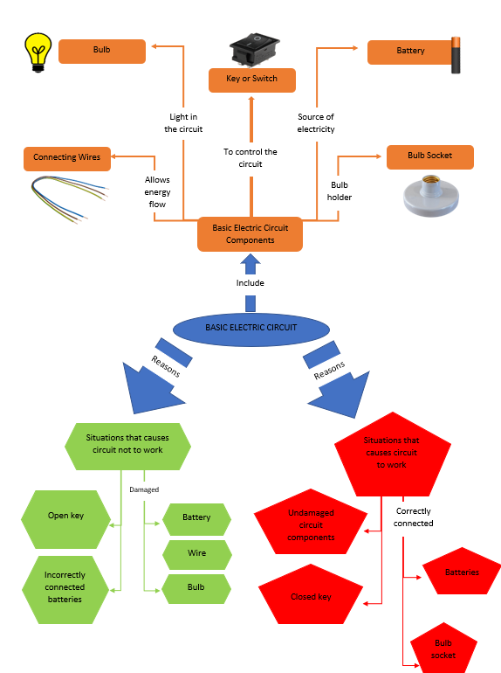

# 4-Courseware Design and Specification

## 4.a) The story of the scenario

In educational software, my main character is a young person who dreams of becoming an agent. In order to achieve his dreams, he studies hard and takes the police exam. While waiting for the result to be announced at home, a phone call comes in and our main character is told that he has passed the exam successfully, so he should come to the interview. Our main character, who is very happy with this situation, goes to the FBI building with great excitement because his dreams have come true. When he enters the interview, he meets the chief agent. In the interview, he tells the main agent's expectations from our main character and what our main character should do. Our main character has a long and difficult road ahead of him. In this process, Agent Simit is assigned to introduce the equipment he will use to our main character, explain his duties, and help him in his duties. The tasks given in the educational software mostly progress to designing the equipment to be used in the spying by creating simple electrical circuits. In missions, sometimes tools break down and our main character needs to fix it, sometimes he goes on a mission and must pass his mission in secrecy, sometimes he builds electrical circuits to see how the tools work. Finally, after successfully completing the warehouse and field missions, he becomes an agent.

## 4.b) Why I choose this scenario is this learning unit

The equipment used in the spy movies I have watched so far has always attracted my attention. In these movies, the agents had a lot of interesting equipment that we couldn't reach in real life, and they were doing all sorts of jobs. When we think about it, electrical circuits

are needed for all electronic equipment to work. Of course, simple electrical circuits are not used as in the subject that I have to teach the students. But I have simplified these equipment.

and included them in my educational software. The subject of spying and the equipment used gave me more than enough opportunity to have students install simple electrical circuits. Besides, since we don't actually see the spy equipment, it has turned into tools that I can do whatever I want using my imagination. For example, I had a device made that opens every door with a single button and compared it to a racing car controller so that students could better visualize this equipment in their minds. As a result, I chose the subject of agents in order to explain the subject of simple electrical circuits in an entertaining way and to benefit from many sources.

## 4.1) Opening Scenes

metin, oyuncak içeren bir resim

Açıklama otomatik olarak oluşturuldu

metin, portakal içeren bir resim

Açıklama otomatik olarak oluşturuldumetin, tavan içeren bir resim

Açıklama otomatik olarak oluşturuldu

### 4.1.e) Opening Scenes-Task, Screen Objects, Operators, and Messages

In the first scene, there is a big header which is our game’s title with a big agent picture. In other scenes, there are dialogues between our game’s main character, his mother, the chief agent, and the Agent Simit. Moreover, in one scene the Agent Simit explains the function of the buttons.

### 4.1.g) User Actions

There are no user actions on first slides. This parts only tell the story of the educational software.

## 4.2) First Activity

## 

### 4.2.c) Objectives

Students will be able to define some of the components of a simple electrical circuit:

battery, light bulb, wire, and switch

Students will be able to define some of the components of a simple electrical

circuit: battery, light bulb, wire, and switch

Students will be able to comprehend the circuit components’ properties and their

functions.

Students will recall the concepts of battery, wire, light bulb, and electricity.

Students will be able to comprehend the circuit components’ properties and their functions

### 4.2.e) Opening Scenes-Task, Screen Objects, Operators, and Messages

In this scene, the player is given spy glasses that examine the circuit inside the equipment so that they can understand how the agent's equipment works and are asked to do their analysis and then fill in the blanks in the notebook. While the player observes electrical circuits Agent Smith assists with the function of the parts.

### 4.2.f) Ease understanding and strategies

The biggest reason for me to choose a story topic with equipment. To make the subject that I will teach understandable by using equipment visuals. In a nutshell this activity is based on imagery and illustrative examples which can be found in cognitivism.

### 4.2.g) User Action

The player must place the appropriate simple electrical circuit elements in the spaces given in the notebook. For example. The part that powers the equipment is the battery.

### 4.2.h) Cue Message

Agent Simit says “If the equipment is working, this part lights up.”, ” the part that activates the equipment.”, “the part that powers the equipment.”.

### 4.2.i) Feedback Message

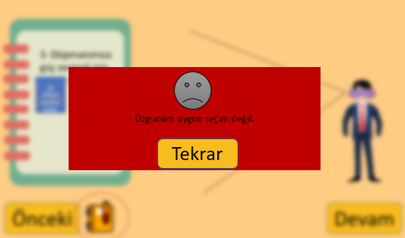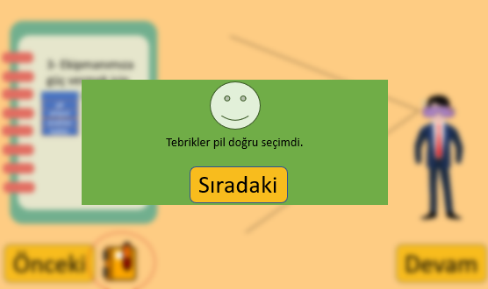

For positive feedback screen. Background blurs and a green pop-up screen with a smiley face icon and a special text message appears in the middle of the screen. All positive feedback screens that will come after that are like this, only the text message changes. In this screen, if player choose right options, positive feedback text message is “congratulations .... is the right choice.(battery, bulb, wire, key)”

For negative feedback screen. Background blurs and a red pop-up screen with a sad face icon and a special text message appears in the middle of the screen. All negative feedback screens that will come after that are like this, only the text message changes. In this screen, , if player choose wrong options, negative feedback text message is “sorry ... is the wrong choice (battery, bulb, wire, key).”

### 4.2.l) Practice The Software

This activity is only to examine the inside of the equipment and get an idea about the equipment. Player will use the equipment learned in this activity in other activities.

### 4.2.m) Help/Scaffold the software provides

Agent Simit's words during the equipment observation process are helpful in practice.

## 4.3) Second Activity

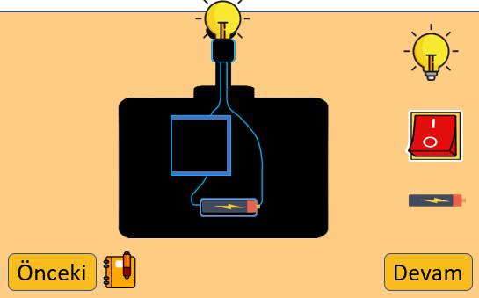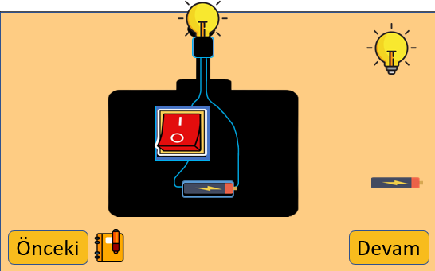

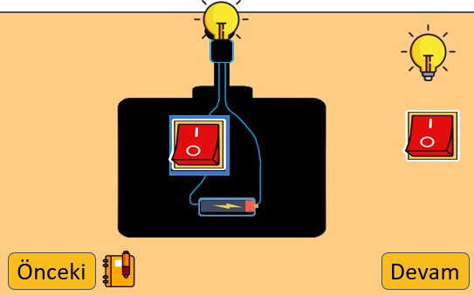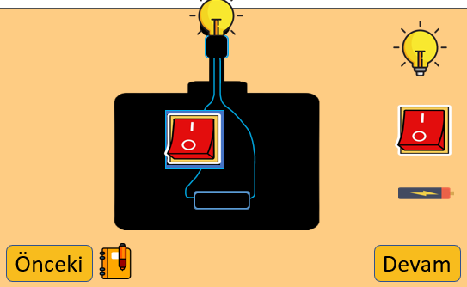

### 4.3.c) Objectives

Students will recall the concepts of battery, wire, light bulb, and electricity.

Students will be able to define some of the components of a simple electrical circuit:

battery, light bulb, wire, and switch

Students will be able to comprehend the circuit components’ properties and their functions

### 4.3.d) How do I overcome learning difficulties/misconceptions in accomplishing the objective

Some studies indicates that it is difficult for a middle school student to learn the concepts they know in daily life in scientific terms. For example, the thing they know as lamp is now called bulb. In the activity, I use both lamb and bulb on text messages and game. By using the two words together in the activities, I made the students get used to the fact that the two words are the same.

### 4.3.e) Opening Scenes-Task, Screen Objects, Operators, and Messages

There is a table background and in the middle of the table is a controller similar to a toy car controller. The controller’s name is “Kapıaçus”. The visible part of the controller is the internal structure of the controller. Simple electrical circuit parts are added inside the controller with boxes. each screen has missing a piece. On the right side, There are three basic electric circuit components. Components are movable.

### 4.3.f) Ease understanding and strategies

The biggest reason for me to choose a story topic with equipment. To make the subject that I will teach understandable by using equipment visuals. In a nutshell this activity is based on imagery and illustrative examples which can be found in cognitivism.

### 4.3.g) User Actions

The second activity is based on replacing the missing equipment with new ones. this is a drag and drop activity. to avoid confusion. There is only one missing part in the equipment. The player is asked to find which of these pieces are and place the correct piece.

### 4.3.h) Cue Message

Agent Simit says respectively these “The first equipment I will give you does not light up.”, “The key required for the work of the second equipment is broken.”, ” the powering part of the last equipment is missing.”

### 4.3.i) Feedback Message

In this screens, if the drag and drop event dragged the wrong component to the right place negative feedback text message is “sorry ... is the wrong choice (battery, bulb, wire, key).”

In this screens, if the drag and drop event dragged the right component to the right place positive feedback text message is “congratulations .... is the right choice.(battery, bulb, key)”

### 4.3.l) Practice The Software

This activity is an activity on how to place simple electrical circuit elements in a control. The purpose of the activity is to complete the missing parts in order for the simple electrical circuit to work and to see the equipment that should be used while creating the circuit in this way. The reinforcement activity of this activity will also be included in the next upcoming events.

### 4.3.m) Help/Scaffold the software provides

Agent Simit's words during the equipment observation process are helpful in practice.

## 4.4)Third Activity

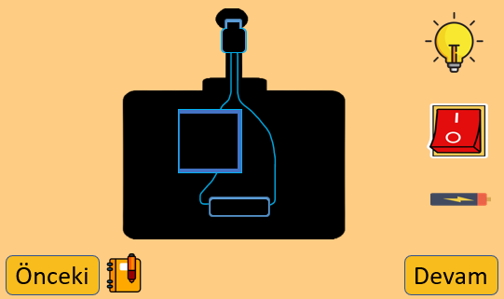

### 

### 4.4.c) Objectives

Students will recall the circuit elements that make up the simple electric circuit and their functions, from the previous learned information.

Students will recall the concepts of battery, wire, light bulb, and electricity.

Students will be able to define some of the components of a simple electrical circuit:

battery, light bulb, wire, and switch

Students will be able to comprehend the circuit components’ properties and their functions

### 4.4.d) How do I overcome learning difficulties/misconceptions in accomplishing the objective

Students turn on the switch to light the light bulb they use in their daily lives. However, when we examine a simple electrical circuit, students realize that when I turn off the switch, the light turns on. To beat this misconception, The text message emphasizes throughout the game that the player must turn off the switch to turn on the light

### 4.4.e) Opening Scenes-Task, Screen Objects, Operators, and Messages

There is a table background and in the middle of the table is a controller similar to a toy car controller. The controller’s name is “Kapıaçus”. The visible part of the controller is the internal structure of the controller. Simple electrical circuit parts are added inside the controller with boxes. The controller that does not contain any of the electrical circuit equipment. the task is to place the correct parts in the gaps in the equipment.

### 4.4.f) Ease understanding and strategies

The biggest reason for me to choose a story topic with equipment. To make the subject that I will teach understandable by using equipment visuals. In a nutshell this activity is based on imagery and illustrative examples which can be found in cognitivism.

### 4.4.g) User Actions

### this part is drag and drop activity. The player's aim is to make his/her own equipment by dragging the right pieces to the right places. Player needs to drag the circuit components into the right place respectively.

### 4.4.h) Cue Message

There is no cue message in this part.

### 4.4.i) Feedback Message

In this screens, if the drag and drop event dragged the wrong component to the right place negative feedback text message is “sorry ... is the wrong choice (battery, bulb, wire, key).”

In this screens, if the drag and drop event dragged the right component to the right place positive feedback text message is “congratulations .... is the right choice.(battery, bulb, key)”

### 4.4.l) Practice The Software

This activity is reinforcement activity of simple electrical circuit elements.

## 4.5) Fifth Activity

### 4.5.c) Objectives

Students will be able to tell that switches and wires at home and at school are circuit components.

Students will recall the concepts of battery, wire, light bulb, and electricity.

Students will be able to define some of the components of a simple electrical circuit:

battery, light bulb, wire, and switch

Students will be able to comprehend the circuit components’ properties and their functions

### 4.5.d) How do I overcome learning difficulties/misconceptions in accomplishing the objective

It is hard for the students to learn and imagine that electricity is transmitted along wires. Thinking about this learning difficulties, I designed this activity to show that a wireless circuit cannot work and only electricity can be transmitted if there is a wire.

Since the outside of the cables is plastic, students think that electricity passes through a plastic material. When we bring wires for students to examine, they can observe that there are metal cables that conduct electricity in wires. Thinking about this learning misconception, In this activity, I am asked to place conductive cables inside a plastic cable slot

### 4.5.e) Opening Scenes-Task, Screen Objects, Operators, and Messages

In this screen, unlike the previous screens, there is an equipment that stands horizontally, and other electrical circuit elements other than cables are placed in the equipment properly. on the right, split cable pieces waiting to be inserted

### 4.5.f) Ease understanding and strategies

The biggest reason for me to choose a story topic with equipment. To make the subject that I will teach understandable by using equipment visuals. In a nutshell this activity is based on imagery and illustrative examples which can be found in cognitivism.

### 4.5.g) User Actions

This activity is a drag and drop activity in the form of a puzzle. The aim is to place the cables that have been cut into pieces in the appropriate places.

### 4.5.h) Cue Message

The message is “You have to examine the parts and the blanks.”

### 4.5.i) Feedback Message

In this screens, if the drag and drop event dragged all cables to the right places positive feedback text message is “congratulations all cables are connected and the tool works”

In this screens, if the drag and drop event dragged a cables to the wrong place negative feedback text message is “congratulations all cables are connected and the tool work”

### 4.5.l) Practice The Software

In the previous activities, the cables were always ready, this time I did some activity to place the cables. Without wires, the electrical circuit cannot work.

## metin içeren bir resim Açıklama otomatik olarak oluşturuldumetin, sarı içeren bir resim Açıklama otomatik olarak oluşturuldu4.6) Sixth Activity

### 4.6.c) Objectives

Students will be able to show elements in an electrical circuit with symbols.

Students will recall the concepts of battery, wire, light bulb, and electricity.

Students will be able to comprehend the circuit components’ properties and their functions

Students will be able to devise the schematic of the electrical circuit she has created.

### 4.6.e) Opening Scenes-Task, Screen Objects, Operators, and Messages

In this section, the ancient book of the spy appears in order to increase the impressiveness of the story. In this book, spy equipment is described with symbols. The player's task is to establish the connection between symbols and components. This event consists of two parts. The first is to establish a simple electrical circuit with symbols, and the second is to match the symbol with the corresponding components.

### 4.6.f) Ease understanding and strategies

The biggest reason for me to choose a story topic with equipment. To make the subject that I will teach understandable by using equipment visuals. In a nutshell this activity is based on imagery and illustrative examples which can be found in cognitivism.

### 4.6.g) User Actions

There are two activities in these parts. The first activity is the drag and drop activity. The second activity is the matching activity. In the first activity the player has to place the correct symbols in their proper places. In the second activity, it needs to match symbols and components.

### 4.6.h) Cue Message

“The placement of the circuit created with the symbols and the simple electrical circuit is the same.”

### 4.6.i) Feedback Message

On this screen, if he drags the right symbol to the right place player sees positive feedback "congrats this is the right place for..."

On this screen, if he drags the symbol to the wrong place player sees positive feedback "sorry this is the wrong place for..."

## 4-7) Seventh Activity

### metin içeren bir resim Açıklama otomatik olarak oluşturuldu

### 4.7.c) Objectives

Students will be able to show elements in an electrical circuit with symbols.

Students will be able to define some of the components of a simple electrical circuit:

battery, light bulb, wire, and switch

Students will be able to devise the schematic of the electrical circuit she has created.

Students will be able to comprehend the circuit components’ properties and their functions

### 4.7.e) Opening Scenes-Task, Screen Objects, Operators, and Messages

As in the previous screen, there is a device standing horizontally. This time, unlike the other screen, the place of the components is empty. there are components symbols on the right side.

### 4.7.f) Ease understanding and strategies

The biggest reason for me to choose a story topic with equipment. To make the subject that I will teach understandable by using equipment visuals. In a nutshell this activity is based on imagery and illustrative examples which can be found in cognitivism.

### 4.7.g) User Actions

On this screen, the user is expected to drag the correct symbols to the appropriate place.

### 4.7.h) Cue Message

There is no cue message.

### 4.7.i) Feedback Message

On this screen, if he drags the right symbol to the right place player sees positive feedback "congrats this is the right place for... symbol"

On this screen, if he drags the symbol to the wrong place player sees positive feedback "sorry this is the wrong place for...symbol"

### 4.7.l) Practice The Software

This activity is a reinforcement activity for simple electrical circuit elements symbols. last event on the topic of symbols.

## 4.8) Eighth Activity

### 4.8.c) Objectives

Students will recall the circuit elements that make up the simple electric circuit and their functions, from the previous learned information.

Students will be able to apply the variables to the circuit after estimating the variables that affect the bulb brightness in an electrical circuit.

Students will be able to relate the number of batteries to the brightness of the bulb.

Students will be able to predict what variables affect bulb brightness in an electrical circuit.

Students will be able to define some of the components of a simple electrical circuit:

battery, light bulb, wire, and switch

Students will be able to comprehend the circuit components’ properties and their functions

### 4.8.e) Opening Scenes-Task, Screen Objects, Operators, and Messages

Unlike the screens used before, we have an improved equipment for this sever. Multiple batteries and bulbs can be installed in this equipment. The biggest difference of this activity from other activities is the test button at the bottom right. After the changes, the player can test the device and observe the change in the brightness of the bulb.

### 4.8.f) Ease understanding and strategies

The biggest reason for me to choose a story topic with equipment. To make the subject that I will teach understandable by using equipment visuals. In a nutshell this activity is based on imagery and illustrative examples which can be found in cognitivism.

### 4.8.g) User Actions

This activity is a drag and drop activity the user needs to make the circuit more luminous by using extra components. so he tests the circuit by adding batteries and light bulbs to the circuit.

### 4.8.h) Cue Message

“You can observe the changes you have made by clicking the try button.”

### 4.8.i) Feedback Message

There is no positive and negative feedback messages. Unlike previous events, this event has a feedback screen showing the brightness change screen. This feedback are “bulb brightness decreased” and “bulb brightness increased”.

### 4.8.l) Practice The Software

First activity on the topic of factors causing changes in bulb brightness. The next activity will be the reinforcement activity of this subject.

## 4.9) Nineth Activity

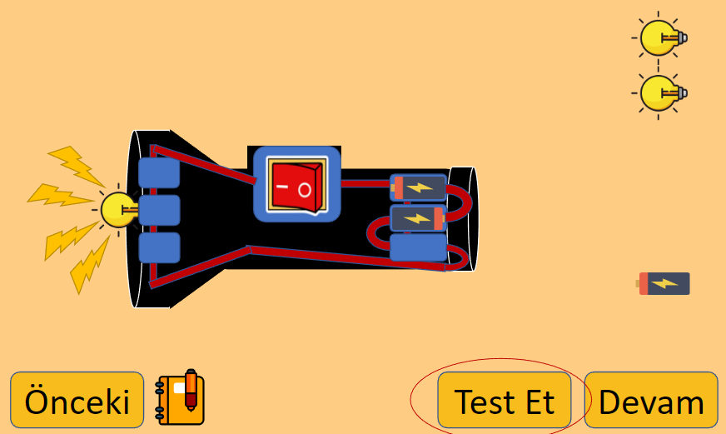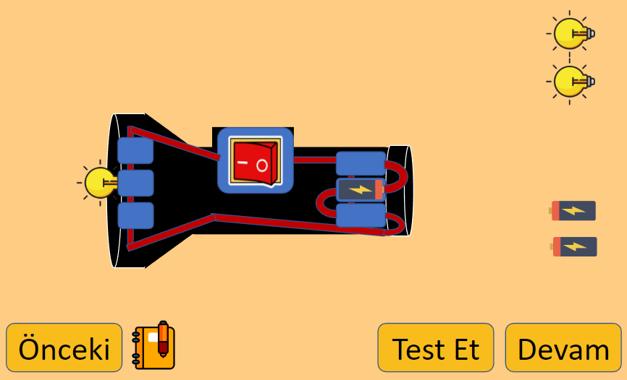

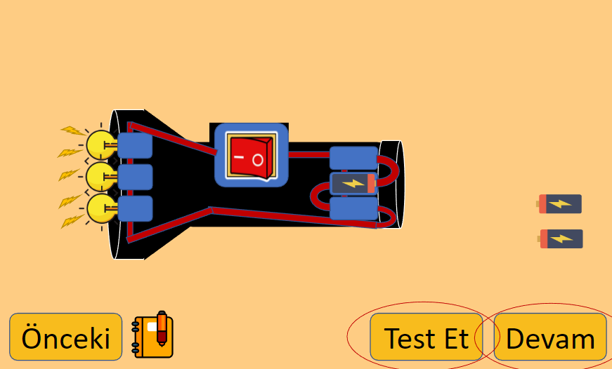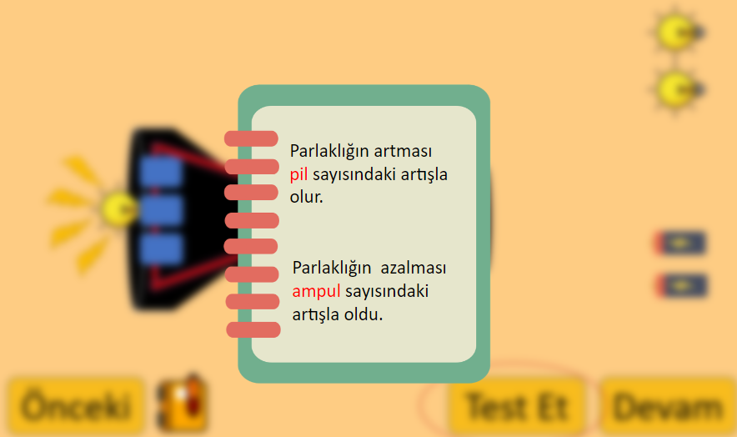

### 4.9.c) Objectives

Students will be able to define some of the components of a simple electrical circuit:

battery, light bulb, wire, and switch

Students will be able to apply the variables to the circuit after estimating the variables that affect the bulb brightness in an electrical circuit.

Students will be able to relate the number of batteries to the brightness of the bulb.

Students will recall the circuit elements that make up the simple electric circuit and their functions, from the previous learned information.

Students will be able to predict what variables affect bulb brightness in an electrical circuit.

### 4.9.e) Opening Scenes-Task, Screen Objects, Operators, and Messages

This screen uses a new equipment this equipment is the agent flashlight. The player must construct a low-light torch for his field mission. On the right, there are electrical circuit equipment that you can add to your device. Player can test his additions to the lantern.

### 4.9.f) Ease understanding and strategies

The biggest reason for me to choose a story topic with equipment. To make the subject that I will teach understandable by using equipment visuals. In a nutshell this activity is based on imagery and illustrative examples which can be found in cognitivism.

### 4.9.g) User Actions

This activity is a drag and drop activity the user needs to make the circuit less luminous by using extra components. So player tests the circuit by adding batteries and light bulbs to the circuit.

### 4.9.h) Cue Message

If the player uses the notes they have taken before, they will see what they wrote in the previous activity.

### 4.9.i) Feedback Message

There is no positive and negative feedback messages. Unlike previous events, this event has a feedback screen showing the brightness change screen. This feedback are “bulb brightness decreased” and “bulb brightness increased”.

### 4.9.l) Practice The Software

Reinforcing effectiveness of the subject of factors affecting lamp brightness

## metin, iç mekan içeren bir resim Açıklama otomatik olarak oluşturuldu4.10) Field Missions

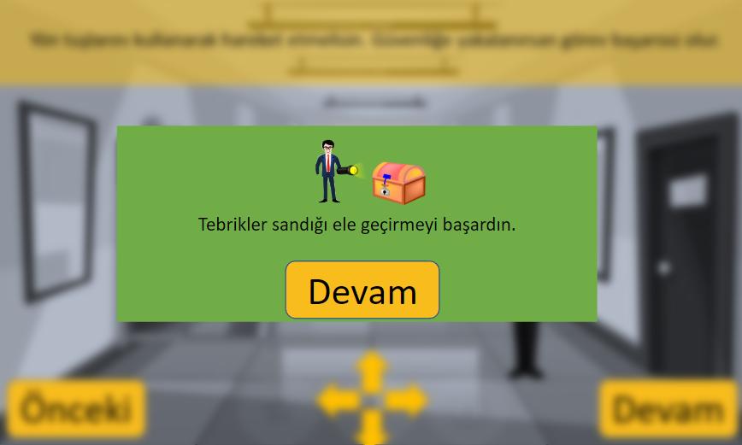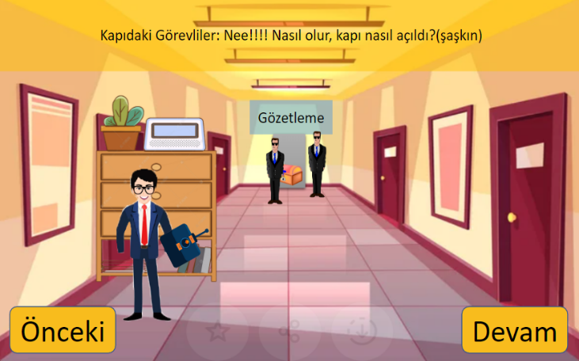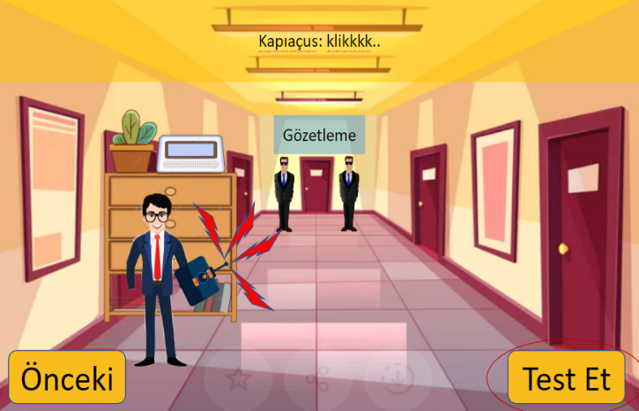

# 5. Justification

This project is designed to make the learning process very enjoyable. Many students who start school may not enjoy school because of the responsibilities, homework, and difficulties in the learning process. My project is meant to make education both easy and fun. The project is designed for 4th grade students. I made the designs and texts as simple as possible so that the project could appeal to the 9-10 age group. The most important criterion was that it was easy to understand, so I used real life examples while designing the equipment I used in the game a toy car controller, remote control, flashlight. In our education system, science lesson is just beginning to be taught in the 4th grade so it's a completely new and complicated start for students. This situation brings with it learning difficulties and misinformation. Moreover, the subject that will remain abstract without giving examples from life.

First of all, as a result of my research, I found many learning difficulties and misinformation about electricity. The main reason misinformation is the concepts we use in our daily life. For example, when we ask someone to turn on the light, we say turn on the light. But when we examine the electrical circuit, we have to turn off the switch to turn on the light. Although this is a situation that occurs because we do not use the key in daily life, it creates confusion for students who are just learning about this subject. Another example is that the cables are plastic coated. In the project, I had to make adjustments to my activities to overcome these concepts, When we deal with learning difficulties, we realize that this subject is actually an abstract subject. Although we hear the concept of electricity all the time, it is complicated for this age group who has no idea how the energy pass through in the cables and what kind of energy it is. I organized the activities to overcome these learning difficulties.

Last but not least, visual designs occupy a very important place for my project. In particular, I had to keep the visuals as simple as possible, since it was a work suitable for the 4th grade age group. I made the page designs, the equipment designs used as familiar as possible. Equipment are designed to ease learning. I designed it as drag-and-drop, puzzle, fill-in-the-blank activities that I think can be fun and easy for the gameplay part.

In a nutshell, There was a project that I was working on for a semester. Many times I had to make changes in designs, and activities. I learned the points that I should pay attention to in project designs. This process has been a good experience for me.

# 6. Teacher/implementer responsibilities in this courseware

The teacher or implementer should have a good command of the subject and educational software. The teacher or implementer should be confident while explaining the project and should inform the user about all the aspects of the project. The teacher should be able to answer any questions from the students in the process of playing this educational software. Although there are instructions in the educational software, the teacher needs to know about the gameplay of the educational software. Because the classes are overcrowded. The teacher who wants to use this software in the lesson should wait for the student to give the answers during the progress process.

# 7. References

1. Küçüközer, H., & Kocakülah, S. (2007). Secondary School Students' Misconceptions about Simple Electric Circuits. Online Submission, 4(1), 101-115.

<https://files.eric.ed.gov/fulltext/ED564331.pdf>

1. Widodo, W., Rosdiana, L., & Fauziah, A. M. (2018, November). Revealing Student’s Multiple- Misconception on Electric Circuits. In Journal of Physics: Conference Series (Vol. 1108, No. 1, p. 012088). IOP Publishing.

<https://iopscience.iop.org/article/10.1088/1742-6596/1108/1/012088/pdf>

<https://pstt.org.uk/application/files/5915/2717/3121/Common_Misconceptions_Spring_2018.pdf>

1. Duit, R., & von Rhöneck, C. (1997). Learning and understanding key concepts of electricity. *Connecting research in physics education with teacher education*, *1*, 1-6.

<https://www.researchgate.net/profile/Lillian-C-Mcdermott/publication/254604913_STUDENTS'_CONCEPTIONS_AND_PROBLEM_SOLVING_IN_MECHANICS/links/56266bb808aed3d3f1383e6d/STUDENTS-CONCEPTIONS-AND-PROBLEM-SOLVING-IN-MECHANICS.pdf#page=50>

1. Mualem, R., & Eylon, B. S. (2010). Junior high school physics: Using a qualitative strategy for successful problem solving. *Journal of Research in Science Teaching*, *47*(9), 1094-1115.

<https://onlinelibrary.wiley.com/doi/full/10.1002/tea.20369>

1. Kauertz, A., & Fischer, H. E. (2006). Assessing students’ level of knowledge and analysing the reasons for learning difficulties in physics by Rasch analysis. *Applications of Rasch measurement in science education*, 212-246.

<https://www.researchgate.net/profile/Hans-Fischer/publication/281345380_Assessing_Students'_Level_of_Knowledge_and_Analysing_the_Reasons_for_Learning_Difficulties_in_Physics_by_Rasch_Analysis/links/560f9c8808ae48337517e915/Assessing-Students-Level-of-Knowledge-and-Analysing-the-Reasons-for-Learning-Difficulties-in-Physics-by-Rasch-Analysis.pdf>